Note:

This document consists of 2 parts:

Part 1: Guidelines for Completing the Risk Assessment Form
This part contains the instructions on completing the Risk Assessment Form.

Part 2: Risk Assessment Form
Applicant is required to submit this part to CAAS as part of the permit application package.

Only a completed Risk Assessment Form will be reviewed and processed for approvals. Applicants are advised to provide a detailed submission.

Part 1: Guidelines for Completing the Risk Assessment Form

The purpose of the Risk Assessment Form is for the operator to consider all hazards which are possible during the intended UAS operation. There are 2 sections in the Risk Assessment Form to be completed.

Section A: Risk Assessment for Required Type of Operation(s)

Based on the type of operation(s) required for the application (e.g. aerial photography, inspection, etc.), this section should detail all possible hazards associated with the identified type of operation(s).
Section B: Risk Assessment for Area of Operations

This section should detail all possible hazards encountered in the vicinity of the area of operations as requested in the application.

Filling in the Risk Assessment Form

Hazard
The following hazards associated with the normal operation of the UAS should minimally be considered:
- Mid-air collision with other UAS / public structure(s)
- Loss of UAS control in-flight due to strong wind or turbulence
- UAS catches fire during flight
- Uncontrolled crash landing
- Others (e.g. collision with other property, environmental considerations, etc)

Phase(s) of Flight
This corresponds to the various phase(s) of flight in which the identified hazard can occur:

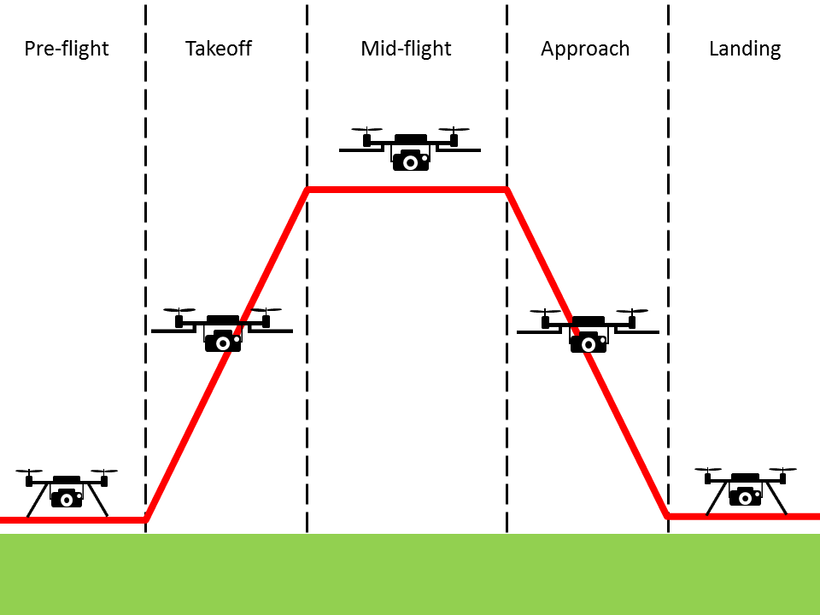

Consequence(s)
This should detail the potential consequences that would result if the identified hazard should occur.

Causal Factor(s)
The various factors that would potentially contribute to the identified hazard.

Control/Recovery Measures
This should detail the mitigation actions to be taken for the identified hazard.

Risk Level after Measures
The risk severity and probability have to be assessed in association with the identified hazard after the mitigation measures are in-placed, using the risk severity category table below.

Personnel-in-charge
Include the pilot and personnel-in-charge/safety personnel and his/her/their role in the UAS operation.

Risk Severity Category

Risk Probability  Either qualitative or quantitative assessment | Risk Severity
 | Catastrophic | Hazardous | Major | Minor | No effect
Probable  Anticipate to occur >=1x during the entire system/operational life of an item; or  Once in 1000 to 10,000 (hrs) | High | High | Medium | Low | Low
Remote  Unlikely to occur to each item during its total life. May occur several times in the life of an entire system or fleet; or  Once in 10,000 to 100,000 (hrs) | High | High | Medium | Low | Low
Extremely Remote  Not anticipated to occur to each item during its total life. May occur a few times in the lift of an entire system or fleet; or  Once in 100,000 to 1,000,000 (hrs) | Medium | Medium | Medium | Low | Low
Extremely Improbable  It is not anticipated to occur during the entire operational life of an entire system or fleet; or  Below once in 1,000,000 (hrs) | Low | Low | Low | Low | Low
Failure Condition in a UAS:
A condition having an effect on the UAS, either direct of consequential, which is caused or contributed to by one or more failures or errors considering flight phase and relevant adverse operational or environmental conditions or external events

Catastrophic: Failure would prevent continued safe flight and landing resulting in (a) one or more fatalities or serious injury to persons or major property damage external to the UAS, (b) uncontrolled loss of aircraft

Hazardous: Failure would reduce the capability of the aircraft or the ability of the crew to cope with adverse operating conditions to the extent that there would be the following:
- Physical distress to persons or property damage external to the UAS possibly including injuries
- A large reduction in safety margins or functional capabilities
- Higher workload such that the flight crew cannot be relied upon to perform their tasks accurately or completely.

Major: Failure would reduce the capability of the aircraft or the ability of the crew to cope with adverse operating conditions to the extent that there would be
- Potential for physical discomfort to persons or minor property damage external to UAS
- A significant reduction in safety margin or functional capabilities
- A significant increase in crew workload or in conditions impairing crew efficiency

Minor: Failure would not significantly reduce the aircraft safety and involve crew actions that are well within their capabilities. It may include slight reduction in safety margins or functional capabilities, slight increase in crew workload (e.g. routine flight plan change)

No effect: Failure would have no effect on safety, i.e., operational capability of the aircraft or increase workload of the crew

Risk Level (after minimising procedures taken into account)
H – High
M – Medium
L – Low

Part 2: Risk Assessment Form
(Attached separate sheets where required)

Name of Applicant:
Name of Organisation:
Contact Number: |  | Email :
UAS Model: | Eg. DJI Phantom Vision
Type of Operations: | Eg. Aerial photography
Area of Operations: | Eg. Marina Barrage

S/N | Hazard | Phase(s) of Flight | Consequence(s) | Causal Factor(s) | Control / Recovery Measures | Risk Level after Measures | Personnel-in-charge
Section A: Risk Assessment for Required Type of Operations
E.g. | Accidental flying into restricted airspace | Take-off, Mid-flight, Approach, Landing | Collision with manned aircraft | Lapse in active monitoring of UAS’s position/altitude/heading | Consider people, machine & environment  Pilot must actively monitor UAS flight parameters and maintain UAS within stipulated area of operations.  Ensure continuous radio link between UAS operator and Unmanned aircraft throughout flying phase.  Monitor wind speed in area of operation. Terminate UAS flying when wind speed excess stipulated limits. | High | Pilot Tan Lee  &  Safety officer Lim Bee Seng
1.
2.
3.

S/N | Hazard | Phase(s) of Flight | Consequence(s) | Causal Factor(s) | Control / Recovery Measures | Risk Level after Measures | Personnel-in-charge
Section B: Risk Assessment for Area of Operations
E.g. | Built-up areas in the vicinity of the area of operations | Mid-flight | Drone collides with building and crash lands on nearby people and/or neighbouring building(s). | Loss of visual line of sight between UAS and operator | Consider people, machine & environment  Pilot must maintain visual contact with UAS at all times.  Operate UAS within published radio range.  Maintain safe distance from public roads, buildings and personnel. | Medium | Pilot Tan Lee  &  Safety officer Lim Bee Seng
1.
2.
3.

