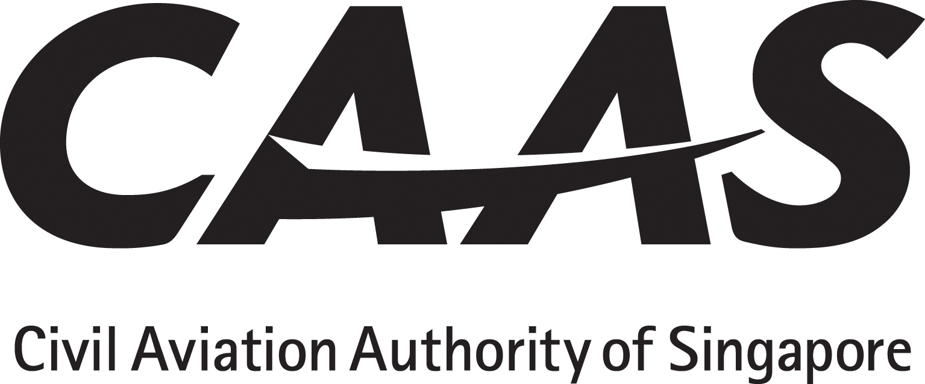
CERTIFIED DESIGNEE CONFIRMATION LETTER
IRREVOCABLE DE-REGISTRATION & EXPORT REQUEST AUTHORISATION
INTERNATIONAL INTERESTS IN AIRCRAFT EQUIPMENT ACT

Date : [Insert date]

To : Civil Aviation Authority of Singapore

Re : Irrevocable De-Registration and Export Request Authorisation (IDERA) –
Confirmation of Certified Designee in relation to the IDERA
[insert the airframe/helicopter manufacturer name and model number] bearing manufacturer’s serial number [insert manufacturer’s serial number] and Singapore registration [number] [mark] [insert registration number/mark].

We, [insert name of authorised party] as “the authorised party” under Schedule 2, Article I of the International Interests in Aircraft Equipment Act (the “Act”), hereby confirm that [insert name, designation of company to be designated] in its capacity as [insert capacity acting under for authorised party] is the certified designee (under the authority of Schedule 2, Article XIII(3) of the Act) in accordance with the confirmations and authorisations in our favour set out in the IDERA authorisation dated [insert date] issued by [insert name of Aircraft operator], the registered operator of the [insert the airframe/helicopter manufacturer name and model number] bearing manufacturer’s serial number [insert manufacturer’s serial number] and Singapore registration [number] [mark] [insert registration number/mark].

Please acknowledge your agreement to this request and its terms by appropriate notation in the space provided below.

[insert name of authorised party]
[Notarisation required]

____________________
By: [insert name of signatory]
Title: [insert title of signatory]
NRIC/FIN/Passport no: [insert identification number]

Agreed to and lodged this
Dated:

____________________
Name:
Title:

CAAS(AW)136
R2, 09/11

